Synopsis

Project Title
End-to-End Machine Learning System for Diabetes Risk Prediction

Problem Id: 14

Student Name – UDDHAV BHARGAVA
University Roll number - 2028889
Section – Q

Student Name – LAKSHYA GUSAIN
University Roll number – 2028753
Section – Q

Student Name – JASMEET SINGH
University Roll number – 2028732
Section – Q

- Problem Description:
Diabetes is a chronic medical condition that affects millions of people globally and can lead to severe complications like heart disease, kidney failure, and nerve damage if not managed early. In real life, early detection is often difficult because symptoms can be subtle. This project aims to bridge that gap by using Machine Learning to analyze clinical data—such as blood pressure, glucose levels, and BMI—to predict a patient's risk of being diabetic. By automating this screening process, healthcare providers can prioritize high-risk patients for further testing, leading to faster intervention, reduced healthcare costs, and significantly better long-term health outcomes for patients.

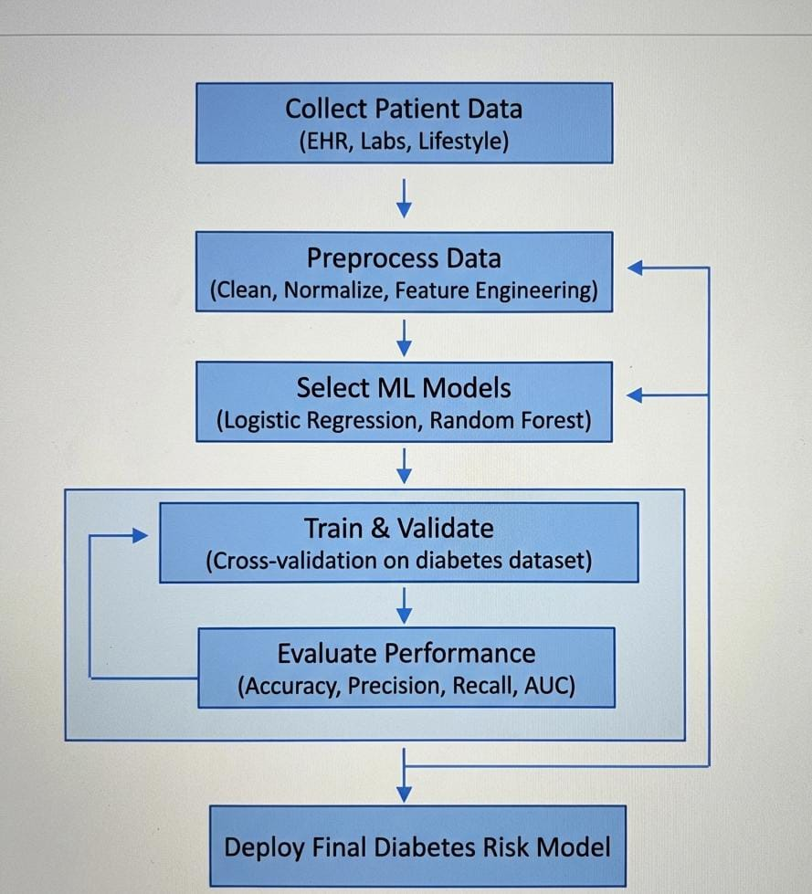

- Steps of Implementation:
- The project follows a standard Machine Learning pipeline as illustrated in the architecture:
- Data Collection: Gathering a diabetes dataset (like the Pima Indians Diabetes Dataset) containing clinical attributes.
- Data Preprocessing:
- Handling Missing Values: Replacing zero or null values in medical measurements (like insulin) with averages or medians.
- Outlier Removal: Using statistical methods to remove "impossible" data points that might skew results.
- Scaling: Using Normalization or Standardization so that features like "Age" (0–100) and "Glucose" (0–200+) are treated with equal importance by the model.
- Feature Selection: Identifying which medical markers (e.g., Glucose vs. Skin Thickness) are most predictive of diabetes to simplify the model.
- Model Selection & Training: Implementing and training three specific algorithms: Logistic Regression, K-Nearest Neighbors (KNN), and Support Vector Machines (SVM).
- Evaluation: Comparing the performance of these models using various metrics to find the most reliable predictor.
- Final Model: Saving the best-performing model to make future predictions where 0 represents Non-Diabetic and 1 represents Diabetic.

- Expected Modules/ Libraries to be used :
- Pandas: Used for data manipulation, loading the CSV dataset, and cleaning medical records.
- NumPy: Used for performing high-level mathematical operations on the numerical arrays of health data.
- Scikit-Learn (sklearn): The core library for implementing the ML models (LR, KNN, SVM) and preprocessing tools like StandardScaler.
- Matplotlib / Seaborn: Used for creating visual charts like the Confusion Matrix and ROC curves to analyze model performance.

- Expected Evaluation metrics and Plots to be used:
- Accuracy: To measure the percentage of total correct predictions.
- Precision and Recall: Precision ensures we don't misdiagnose healthy people, while Recall ensures we don't miss actual diabetic patients (critical in healthcare).
- F1-Score: The balance between Precision and Recall.
- Confusion Matrix: A table used to visualize how many patients were correctly or incorrectly classified in each category.
- ROC Curve: A plot that helps us understand the trade-off between the true positive rate and false positive rate at various thresholds.

- Required topics from the subject:
- Supervised Learning: Understanding how to train a model using labeled data where the outcome (Diabetic/Non-Diabetic) is already known.
- Data Transformation: Knowledge of scaling and encoding techniques to make raw medical data readable for computer algorithms.
- Model Optimization: Understanding how to tune parameters (like 'k' in KNN) to improve the accuracy of the system.

- Platform Required:
- Jupyter Notebook: For interactive development and visualization.
- Python 3.13: The primary programming language.

- Books and Link Sources:
- Hands-On Machine Learning with Scikit-Learn, Keras, and TensorFlow by Aurélien Géron.
- Introduction to Machine Learning with Python by Andreas C. Müller and Sarah Guido.
- UCI Machine Learning Repository: Pima Indians Diabetes Database (Dataset Source).
- Scikit-Learn Documentation: Official guide for Logistic Regression and SVM implementation.

